Digital Program Onboarding Handbook

Contents
1 Introduction 3
2 Digital Program Overview 3
3 Digital Program SharePoint Site 3
3.1 What is SharePoint? 3
3.2 SharePoint Access 3
4 Digital Program Group Calendar 3
4 CWB Policies and Procedures 4
4.1 INFOserver 4
4.2 CWB Meetings and Email Protocols 4
4.3 Emergency Info 4
4.4 Building Security 4
4.5 Code of Conduct 4
4.6 Harassment / Discrimination 5
4.7 Non-Smoking Policy 5
4.8 Dress Code/ Scent Guidelines 5
4.9 Email Etiquette and Rules 5
4.10 Email Signatures 5
4.11 HelpDesk 6
4.12 Setting up a Printer(s) on your Desktop/Laptop 7
4.13 Clean Desk Policy 7
4.14 Corporate Office Wi-Fi 7
4.15 Remote Outlook Access 8
4.16 Meeting rooms 8
4.17 How to Book and Use the Digital Program Conference Line 8
4.18 Skype Online Meetings 9

1 Introduction
The guidelines in this handbook apply to all members of the Digital Program. There are links to processes, procedures and key documentation that are to be used for this initiative

2 Digital Program Overview
The Digital Program Overview can be found here: Digital Program Overview

3 Digital Program SharePoint Site

3.1 What is SharePoint?
SharePoint is a web based application that provides a central storage and collaboration space for documents, information, and ideas. A basic definition is to describe SharePoint as a collection of pages, lists, and libraries. The Digital Program SharePoint site can be found at the following URL:
http://sp.cwb.local/projects/pmo2/Digital%20Program/SitePages/Home.aspx

3.2 SharePoint Access
If individuals are not able to access the SharePoint site, please request permission via an email to PMO.ProjectCoordinators@cwbank.com

4 Digital Program Group Calendar
The CWB Digital Program Group Calendar is a shared Outlook calendar that the program has implemented to help streamline the high amount of recurring and ad hoc meetings. To add the shared calendar, please see the following steps:
- Open Calendar -> From Address Book…
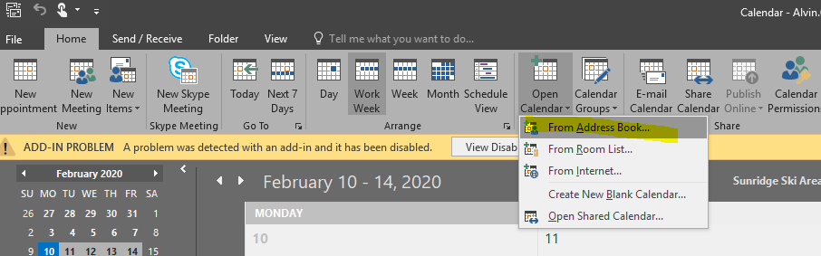
- Type in CWB Digital into the search field to add the CWB Digital Program Group Calendar
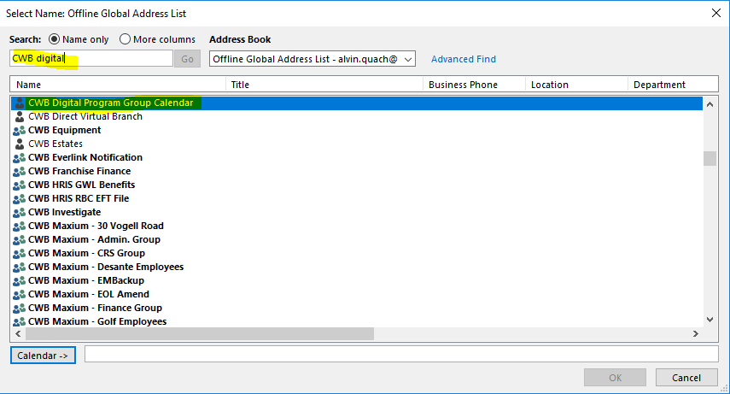
- The calendar should now be available in the left-hand panel on Outlook. You should also have access to view/modify/add/update meetings. If you are not able to perform those actions, please inform the Project Manager or Project Coordinator so that they can submit a HelpDesk ticket on your behalf.

4 CWB Policies and Procedures
Policies and Procedures are like a statement of intent. The following policies and procedures are the protocol and rules to follow within the CWB Group:

4.1 INFOserver
INFOserver is the CWB’s intranet, containing all information regarding CWB policies and procedures, bulletins and updates. It is located at http://infoserver.cwb.local/home.aspx, which is set up as your home page.

4.2 CWB Meetings and Email Protocols
Reference the information on INFOserver for Meeting and Email Protocols that must be observed.

4.3 Emergency Info
Emergency Info contains guidelines for maintaining business continuity during crisis situations such as bomb threats, hostage taking, robberies, earthquakes, fires and power failures. Evacuation information is critical to review.

4.4 Building Security
Building Security provides guidelines for fire and safety, protection of bank property and personal belongings, visitors, damage or theft.

4.5 Code of Conduct

http://infoserver.cwb.local/doc.aspx?id=38655

4.6 Harassment / Discrimination

http://infoserver.cwb.local/default.aspx?cid=32671

4.7 Non-Smoking Policy

http://infoserver.cwb.local/default.aspx?cid=41451

4.8 Dress Code/ Scent Guidelines

http://infoserver.cwb.local/doc.aspx?id=34485

4.9 Email Etiquette and Rules

http://infoserver.cwb.local/default.aspx?cid=39381

4.10 Email Signatures
CWB has internal signatures as outlined below, please ensure you add an internal signature to all emails sent to better communications by either going into File>Options>Mail>Signatures… or within composing a new email Insert>Signature>Signatures within Microsoft Outook. The following is an internal signature:

<First Name> <Last Name> | <Title>, Project Management Office
p. xxx.xxx.xxxx | c. xxx.xxx.xxxx

CWB also has external signature block including the confidentiality clause. This can be by done by either going into File>Options>Mail>Signatures… or within composing a new email Insert>Signature>Signatures within Microsoft outlook. Following is the external signature:


<First Name> <Last Name> | < Title>, Project Management Office
p. xxx.xxx.xxxx | f. 780.969.8308 | c. xxx.xxx.xxxx

Canadian Western Bank | Corporate Office
Suite 3000, 10303 Jasper Avenue, Edmonton, AB, T5J 3X6
p. 780.423.8888 | www.cwbank.com
CONFIDENTIALITY CAUTION
This message is intended only for the use of the individual or entity to which it is addressed and contains information that is privileged and confidential. If the reader of this message is not the intended recipient, or the employee or agent responsible for delivering the message to the intended recipient, you are hereby notified that any disclosure, distribution or copying of this message and any attachments is strictly prohibited. If you have received this message and any attachments in error, please notify the sender immediately, and delete this message and any attachments from your computer system, and refrain from saving or copying this communication or forwarding it to any other recipient, in any form whatsoever. Thank you.

4.11 HelpDesk
The following links to access Help Desk can be found on the INFOserver homepage:

The icon on the left, contact, will open up the Help Desk information page which explains how to contact Help Desk, hours of operations, what types of things Help Desk can assist with, etc.
The icon on the right, self-serve, links to the page where you can review your active incident records that have been reported to Help Desk. You can use this page to close your own tickets if you no longer require help, request updates or view your records. For detailed instructions, please consult this guide. A future release of this page will bring the added functionality of being able to submit incident reports through Self-Service.
If you have questions or suggestions on how to further improve the support you receive via Self-Service, please email: IS-Survey@cwbank.com

4.12 Setting up a Printer(s) on your Desktop/Laptop
Use Cirrato print manager tool to add a printer (example below sets up the Mail Room printer that we use to print in colour).
To install it please perform the following steps.
There is a small triangle to the left of the clock on the bottom right hand corner, double click on it and look for a C red icon and if you hover over it, it should display "Cirrato". Double click on it to open the print manager.
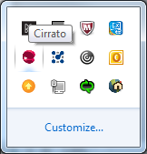
In the CirratoSearch window, under name, enter in: 01_02_MailRmXRX and ensure under Region is set to All regions and click on Search.
Double click on the 01_02_MailRmXRX and it should install. After it's installed, you can right click on it and select default printer.
If there are other printers to install, repeat the steps 2 and 3, just enter in the respective printer name when doing the search.

4.13 Clean Desk Policy
Ensure that all confidential/bank materials are locked up each night (not left on the top of your desks), laptops are locked up if left (not taken home) in a drawer or locked with the laptop cord, and if you leave your desk to CTRL+ALT+DEL (lock) your screens.

Offices and file cabinets that contain bank material/documents should also always be locked at night.

4.14 Corporate Office Wi-Fi

Step | Action
1 | Locate the correct Wi-Fi network:  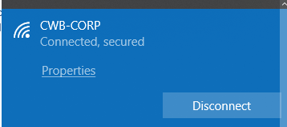
2 | Connect to the network (there is no password)

While in the office, transitioning between wired (docking station) and wireless is seamless. Once you are connected the first time, you’ll be able to take your laptop anywhere in the building and maintain your connectivity without inputting your user credentials or your Authenticator token.
If you have any questions please contact Help Desk.

4.15 Remote Outlook Access
To access Outlook outside of CWB, if you have an iPhone, you need to set up Multi-Factor Authentication (please see the attached instructions):

4.16 Meeting rooms
The following link will provide you with all the necessary information to assist in better utilization of rooms by matching the size and resources needed to conduct your meeting. There is a floor plan attached showing the location of the room.
Corporate Office Meeting Rooms

4.17 How to Book and Use the Digital Program Conference Line
The Digital Program Conference Line should be reserved in Outlook just like a meeting room, by looking it up the following resource name in the Address Book and adding it to the meeting invitation. Please confirm its availability prior to sending the invitation in order to avoid getting a rejection if it is already booked.
Resource Name | Access Code | Chairperson Code
Digital Program Conference Line | 4356930 | 2350

Steps for Chairperson / Meeting Organizer to open the conference line:
- Dial the toll-free Conference Dial-in Number 1-800-662-6992
- When prompted, please enter your Access Code above followed by #.
- When prompted, enter your Chairperson Code above then #.
- When prompted, begin the conference by pressing *.
Note: For security purposes, please do not share the chairperson code.
Steps for Participants to join the conference line:
- Dial the toll-free conference dial-in number: 1-888-882-9090
- When prompted, enter your Access Code above followed by #.
Note: Participants that dial-in prior to the chairperson will be notified that they will join the conference as soon as the chairperson arrives and they will be played music until the conference starts. All participants will be notified when being placed into the conference.
Helpful Tip: Request at the start of the call that if participants are not speaking, they should mute their phones; this will help cut down on background noise.

4.18 Skype Online Meetings
Skype Online is enterprise real-time communications server software which can be used for Instant Messaging, Presence, Conferencing (no video) along with desktop sharing.

If you book a meeting with Skype you are able to share screens with external parties.
You can insert Skype meeting information/links in your Outlook meeting by clicking the Skype Meeting button from your meeting invite:
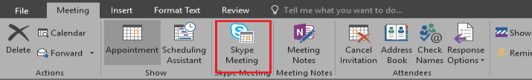
Internal and external resources can then click on the following links in the meeting invite to access the Skype meeting call:
